Activity 1: Template for Arduino and LED Interfacing Activity

Date : 20/11/2025 Batch : A1 Group No. : 4

Statement Given:
Task I: Interfacing of LEDs and pattern generation
- Use Arduino and LED Board to perform following activities
- Different Patterns of LED on- off sequence and duration of on - off time
Task II: Interfacing and controlling of LEDs using Push switch Button provided on LED board.
- Control LED on/off patterns with push button input.
Evaluation Criteria:
- Connections as per task I (Only LED pattern -3 marks)
- Working and Code for Arduino for the Task I - 2 marks
- Connections as per task II (Push Button and LED -3 marks)
- Working and Code for Arduino for the Task II - 3 marks
- LMS submission of template and videos. – 4 marks
Team :
Sr No | Roll No | Name | Work Done
1 |  | Arav Arun | Code and Connections
2 |  | Mohammed Attar | Push Button Power Supply
3 |  | Eshika Arya | Materials and Assistance
4 |  | Omkar Avhad | Code and Connections

Respective codes
Code 1:
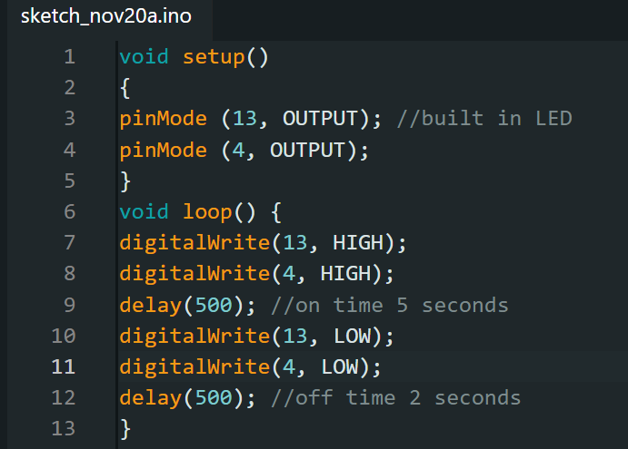
Code 2:
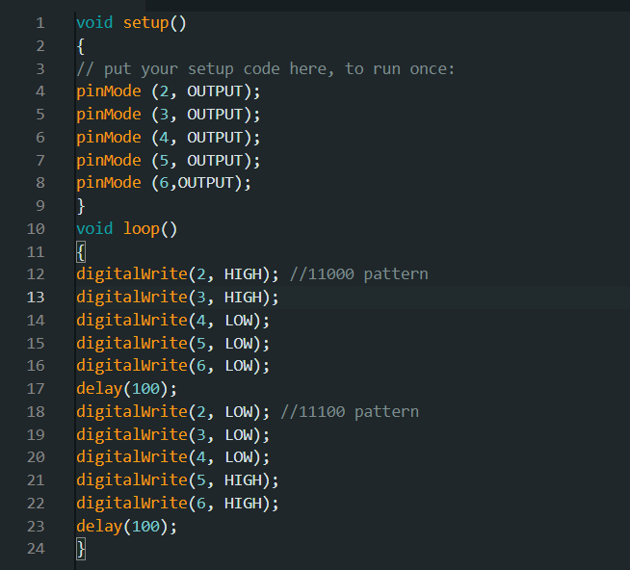

Code 3:
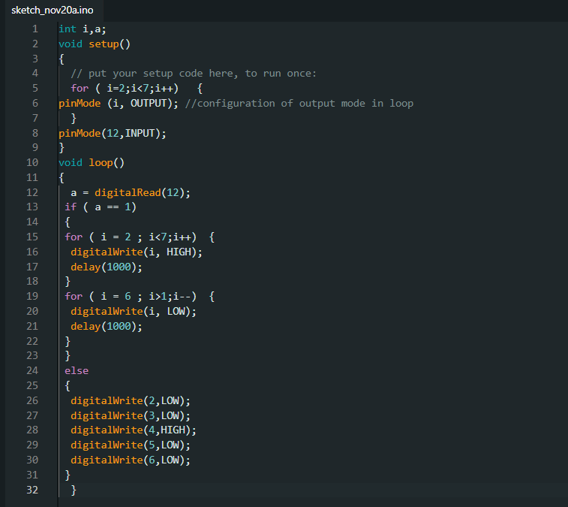

Photo and video of Actual implementation
Activity 1:

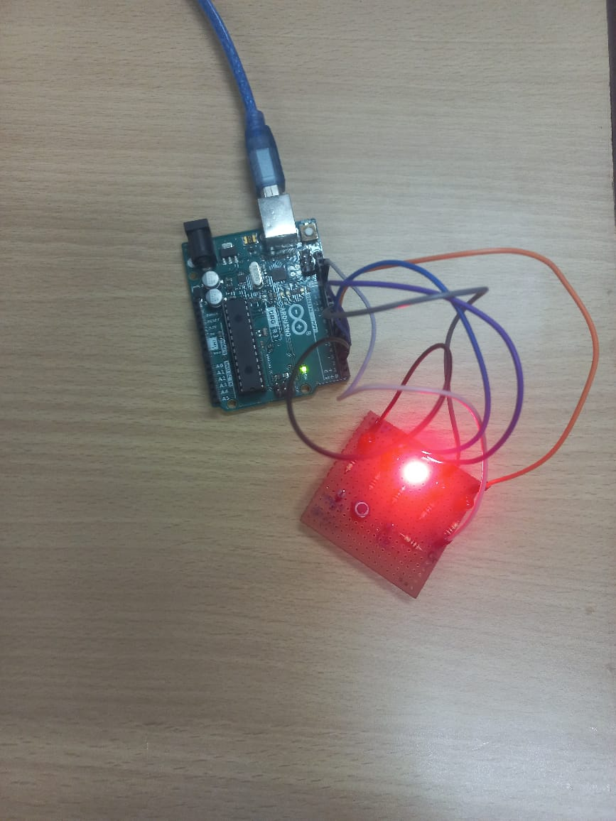
Activity 2:
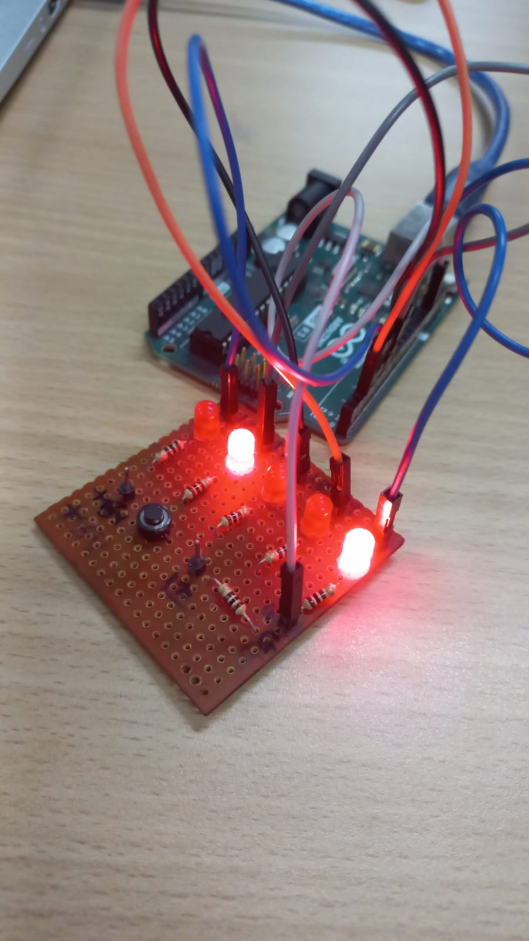
Activity 3:
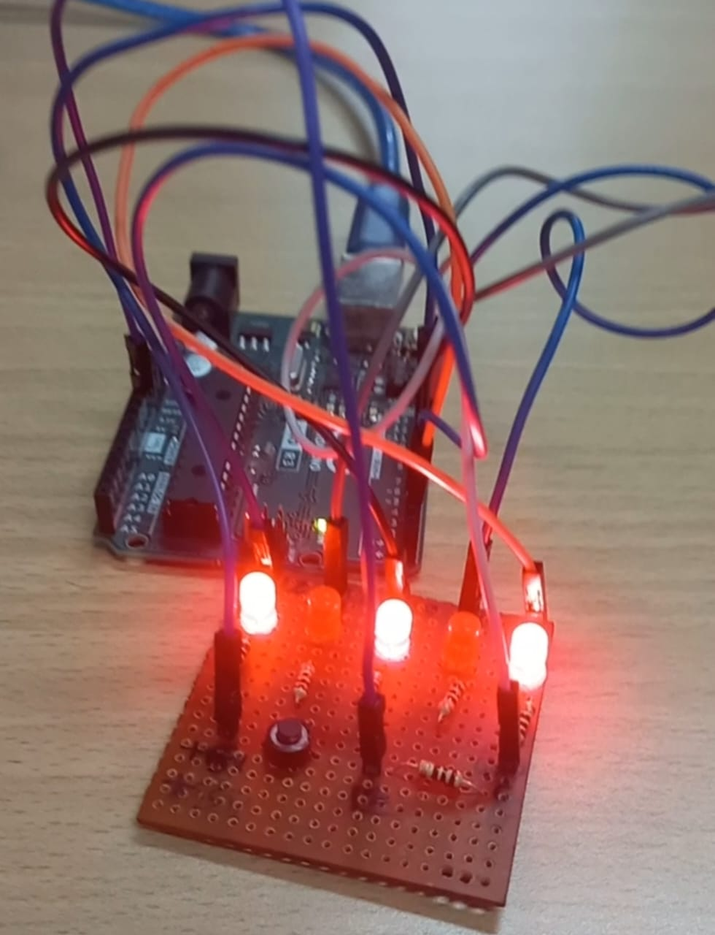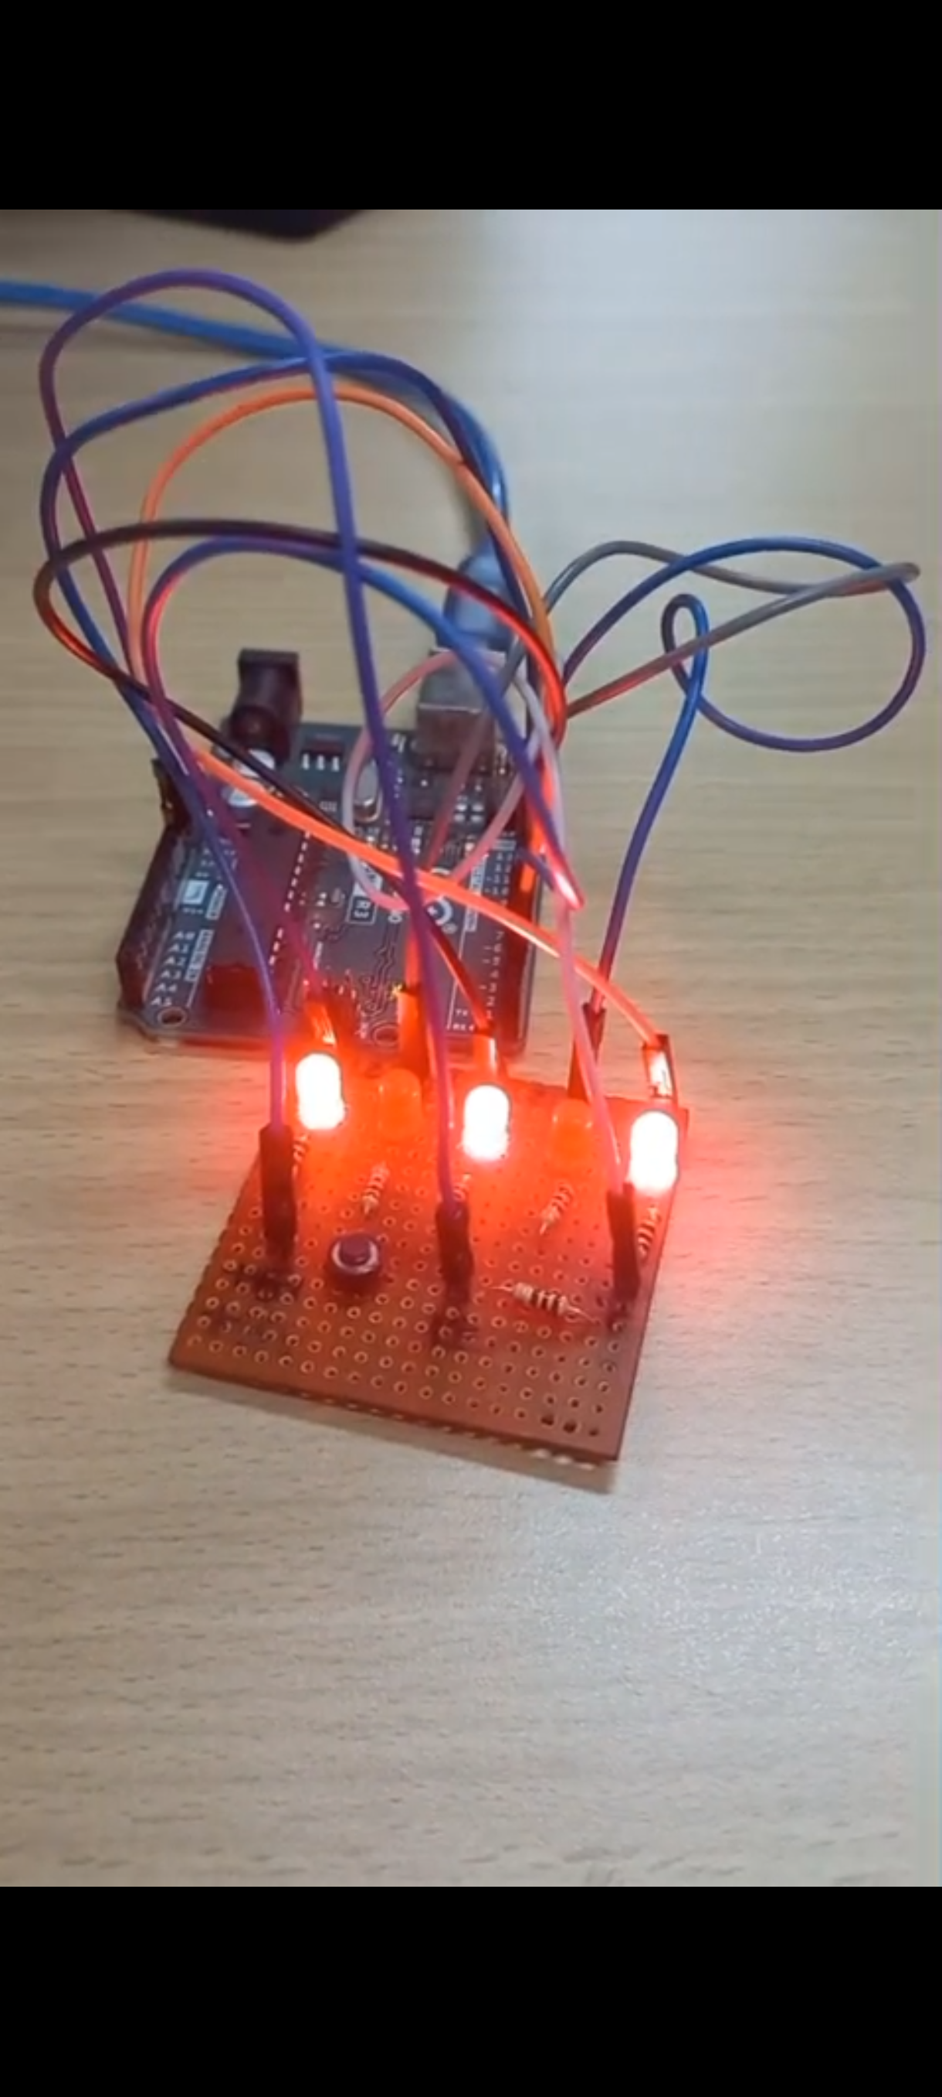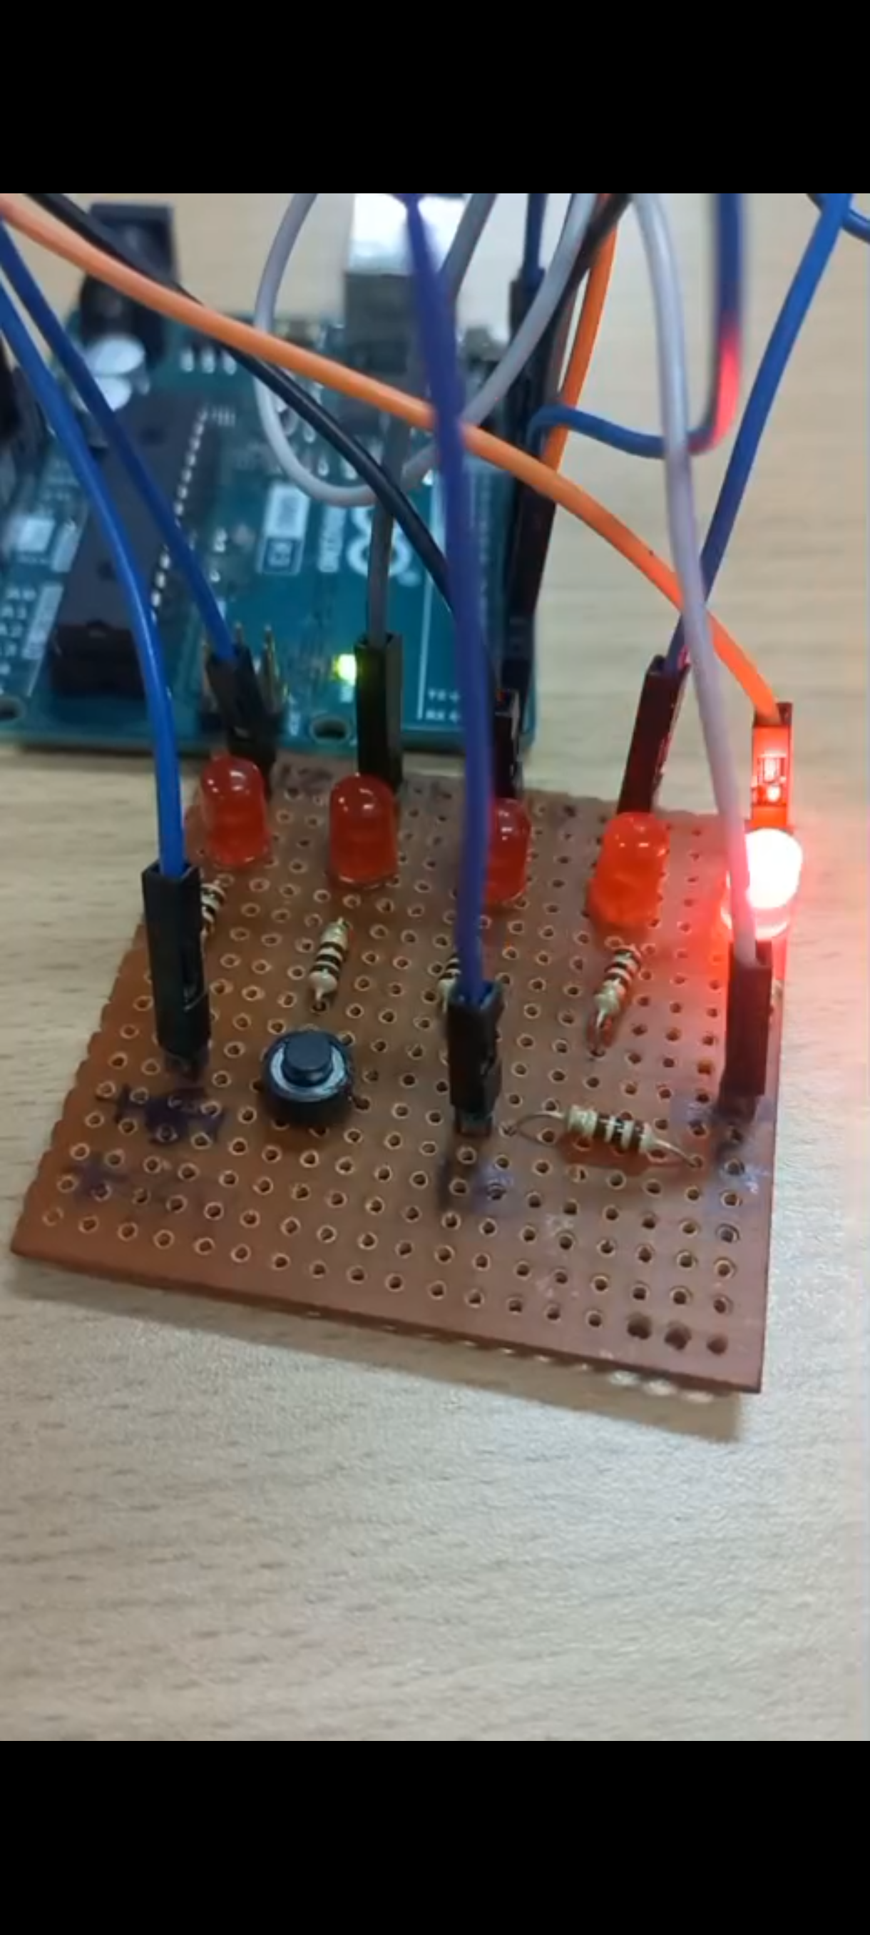

Observations , reflection on activity
- When the input on pin 12 becomes HIGH, the LEDs connected to pins 2 to 6 turn ON one after another from left to right, each lighting for a short moment before turning OFF. After reaching the last LED, the sequence reverses: the LEDs turn ON from right to left in the same manner. This creates a smooth “running” or “ping -pong” light effect.
- If the input on pin 12 is LOW, all LEDs remain OFF.
- The pattern keeps repeating as long as pin 12 stays HIGH.
- This activity helped me understand how loops can be used to create dynamic lighting patterns on the Arduino. By using a for loop in both forward and reverse directions, I learned how to control multiple LEDs efficiently without repeating code. The logic of reading an input pin (pin 12) also showed me how external conditions can activate or deactivate a sequence.
- This exercise improved my understanding of conditional statements, loop control, and timing using delay(). It also demonstrated how simple programming techniques can create visually appealing patterns like those used in displays, indicators, or robotics. Overall, the activity strengthened my ability to combine hardware and code to produce interactive behaviour.

Share the link for your uploaded videos and photos here :
Pbl A1 grp 4 - Google Drive

